6.49: The total mass that can be raised is
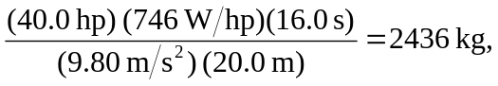
so the maximum number of passengers is 